Assignment: Build a React UI from Figma Design
Objective
Build a responsive front-end application using React by replicating the provided Figma design.
This assignment evaluates your ability to:
- Translate design → pixel-accurate UI
- Structure scalable front-end code
- Handle state, components, and interactions
- Deliver clean, maintainable code

Task Overview
Your task is to replicate the two UI designs below in React as closely as possible, including layout, styling, and basic interactions.
Screen 1: Home screen for Knowledge Base
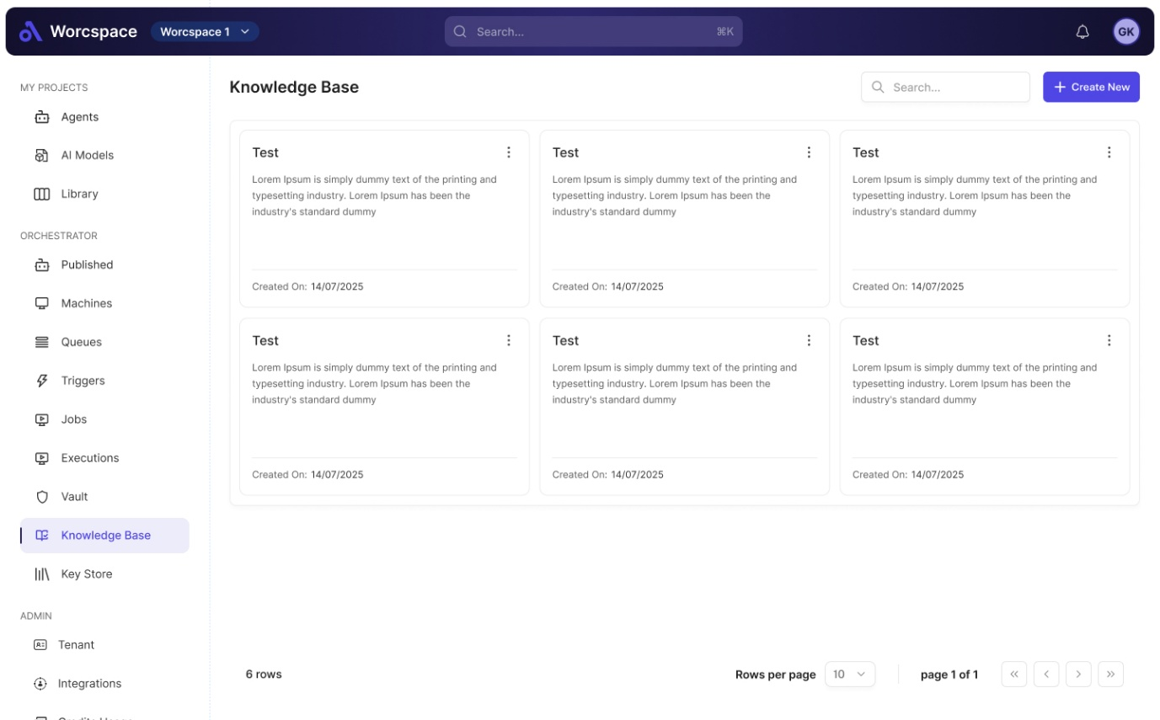

Screen 2: Pop-up screen when user click on ‘Create New’ button.
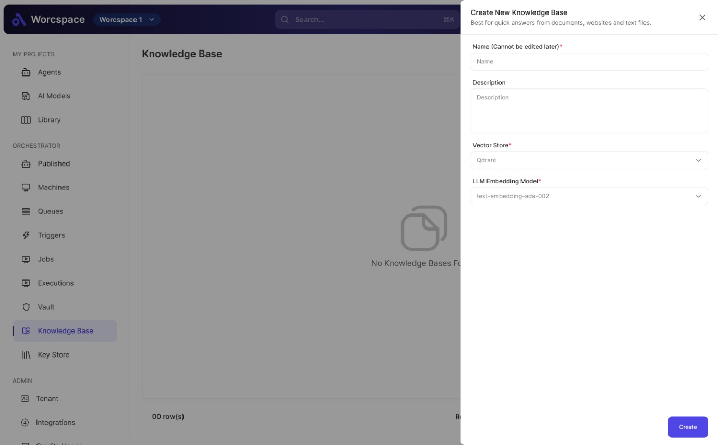

Core Requirements
🔹 1. UI Implementation
- Replicate the Figma design with high visual accuracy
- Maintain proper spacing, typography, colors (Primary Color: HEX #4F46E5 Secondary Color: HEX #1E1B4B), and alignment
- Ensure consistency across components
- ‘Create New’ button must be clickable, rest of the menu bottons / link can be static (non-clickable)

🔹 2. Component-Based Architecture
- Break the UI into reusable components
  - Example: Header, Sidebar, Cards, Buttons, Modals
- Follow a clean folder structure

🔹 3. Code Quality
We will evaluate:
- Code readability and structure
- Reusability of components
- Naming conventions
- Separation of concerns

Tech Stack Guidelines
- Framework: React (preferred with functional components + hooks)
- Styling: Tailwind CSS

Deliverables
Please submit:
- Source Code (GitHub repo preferred)
- Screen Shots of the UI developed
- Live Demo to show the UI in action (optional not mandatory)

